**Customer Relationship Management Web application**

Main page:

Showing list of all customers.

Click on Add a new customer to save new customer information in database.

Click on Update to update that particular customer information in database.

Click on Delete to delete that particular customer information from database.

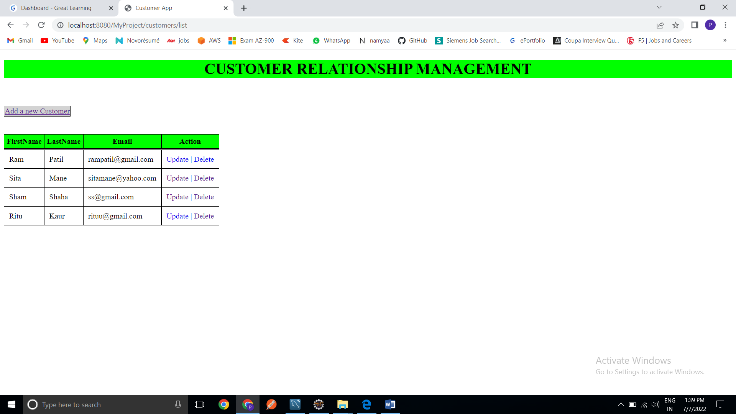

Above is the screenshot of main page.

Upon Click Add a new Customer, user will be redirected to a new Customer form page, wherein the user will enter details and save.

Back to List will redirect user to main page.

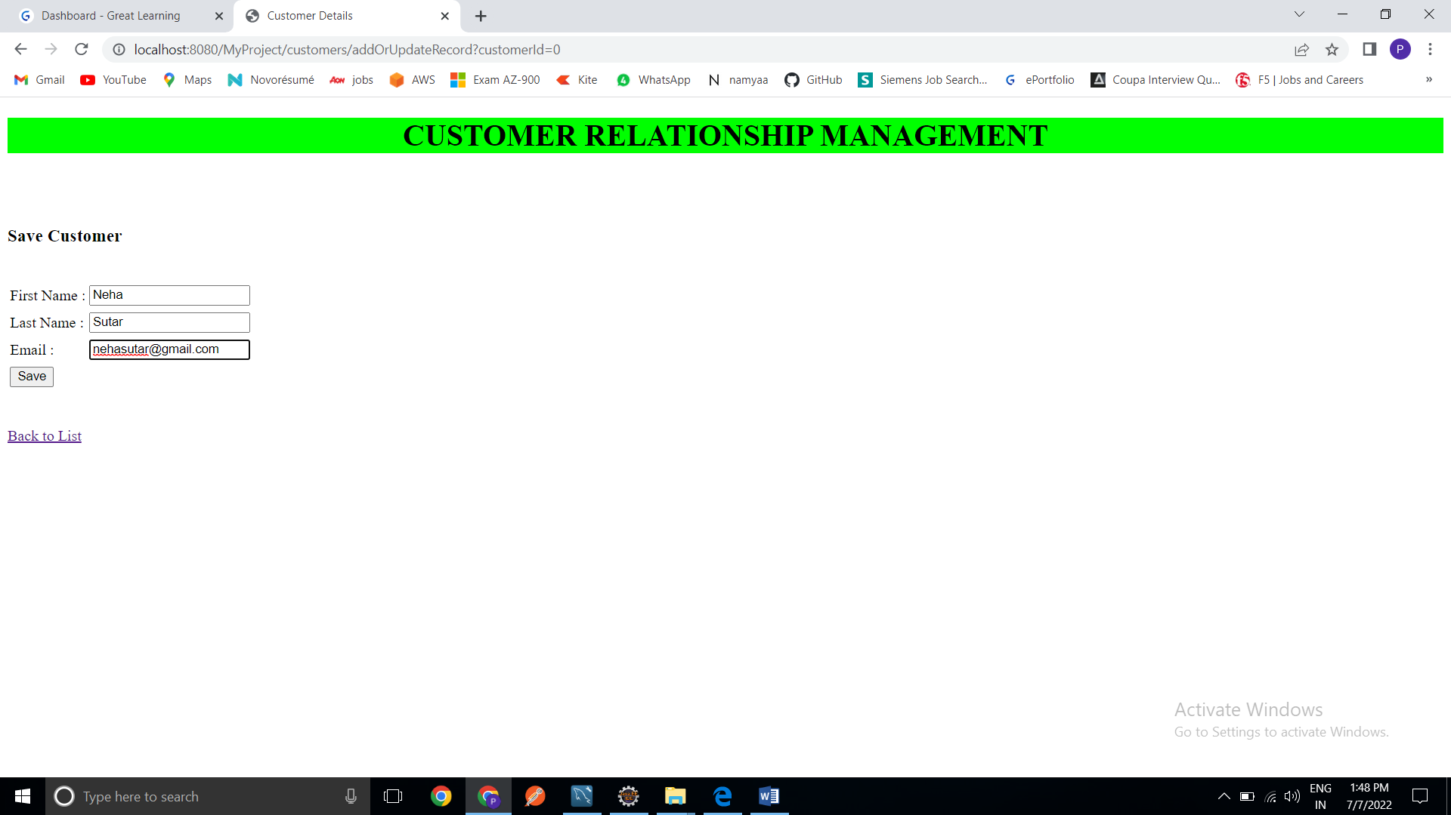

Customer form page, wherein the user will enter details and save.

Updated list of customers after adding a new customer Neha Sutar.

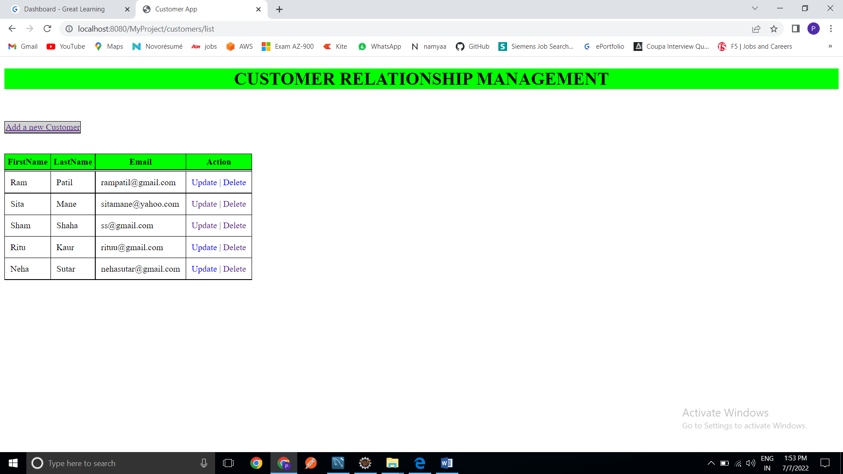

List showing added new customer

Upon clicking the Update the user is redirected to a new page which will consist of the form with pre populated data, after updating the details, upon click on Save button, new data persist in the database.

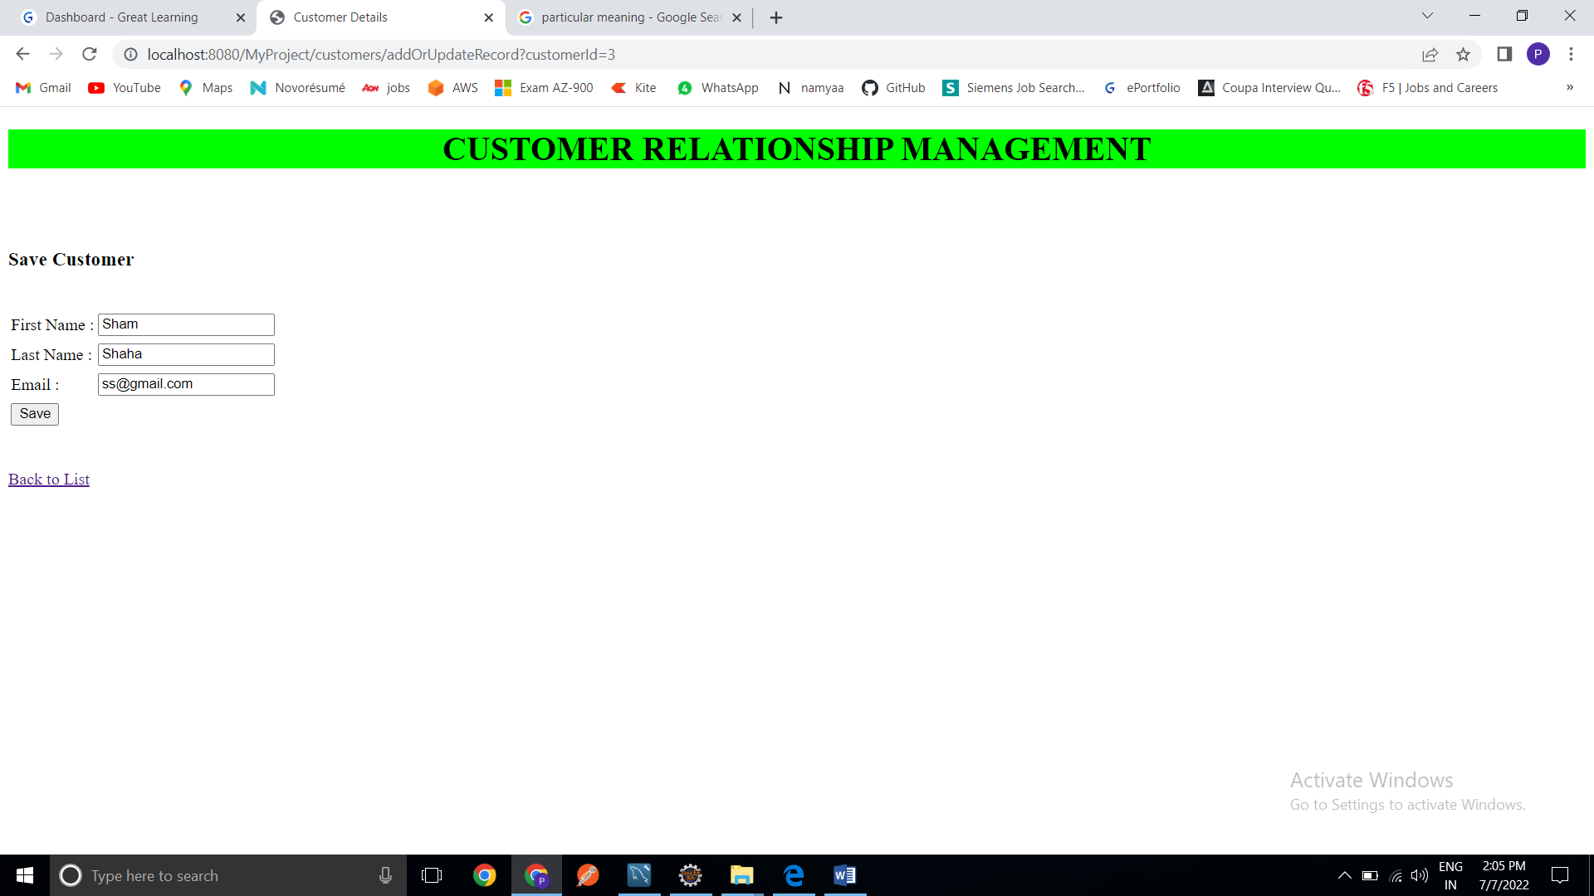

Changed [ss@gmail.com](mailto:ss@gmail.com) to [shamshaha@gmail.com](mailto:shamshaha@gmail.com).

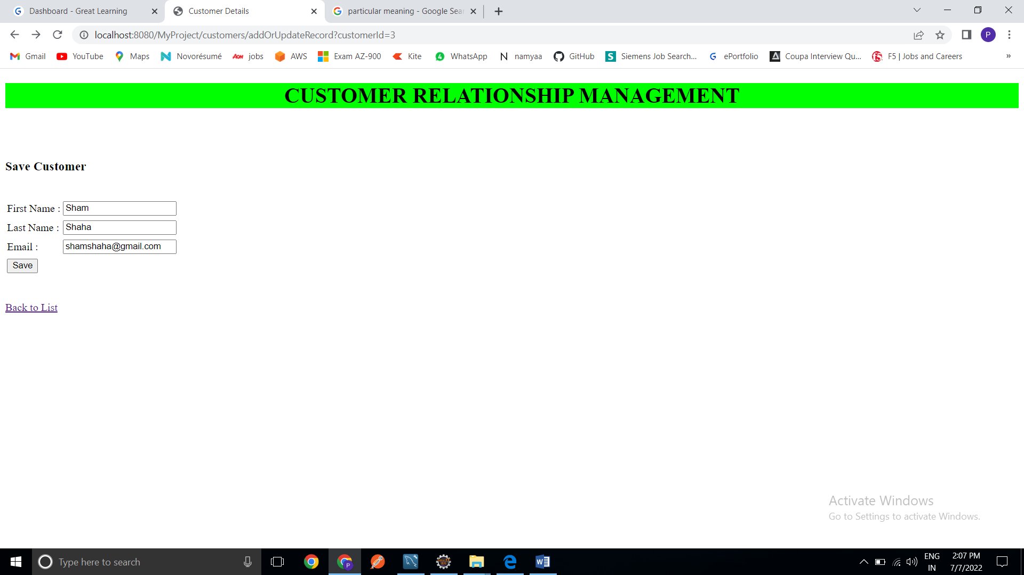

Updated value of Customer Sham Shaha with email old address [ss@gmail.com](mailto:ss@gmail.com) to new email [shamshaha@gmail.com](mailto:shamshaha@gmail.com).

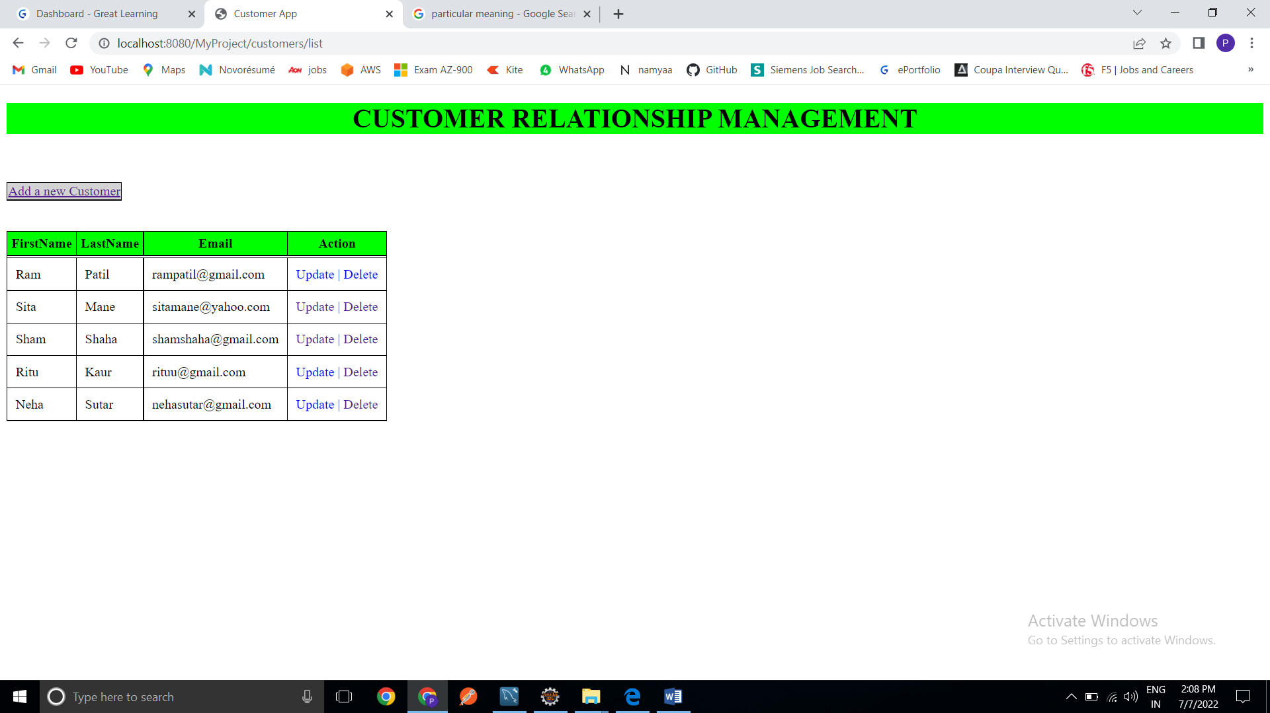

List showing updated customer details

Upon clicking on the Delete, the customer entry get deleted from the database.

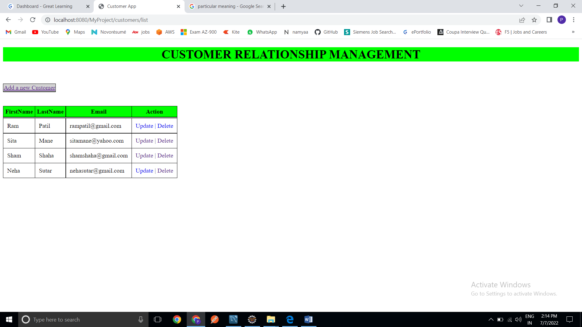

Updated list of employees upon deleting customer Ritu Kaur.